**BRAIN READING ROBOTS**

**[2022FOD009]**

**DEPARTMENT OF INFORMATION TECHNOLOGY**

**Sumalesh K A 2022UIT1048**

1. INTRODUCTION

People express their mental states, including emotions, thoughts, and desires, all the time through facial expressions, vocal nuances, and gestures.This is true even when they are interacting with machines. Our mental states shape the decisions that we make, govern how we communicate with others, and affect our performance. The ability to attribute mental states to others from their behavior and to use that knowledge to guide our own actions and predict those of others is known as the theory of brain or mind-reading.

2. BRAIN READING

Brain reading can be said as the ability to where electrical activity in the human brain can be interrogated and manipulated. This is done to understand what biochemistry the brain does for the body. For example, a doctor can examine your body and tell the potential diseases by detecting your body. In a similar context, monitoring of electrical activity can be done to reveal any neurological illness. It can also help in understanding brain conditions like ADHD and schizophrenia.

* 1. Why Brain Reading?

The Brain -reading computer system presents information about your mental state as easily as a keyboard and mouse present text and commands. Imagine a future where we are surrounded with mobile phones, cars and online services that can read our minds and react to our moods. How would that change our use of technology and our lives? We are working with a major car manufacturer to implement this system in cars to detect driver mental states such as drowsiness, distraction and anger. Current projects in Cambridge are considering further inputs such as body posture and gestures to improve the inference. We can then use the same models to control the animation of cartoon avatars.

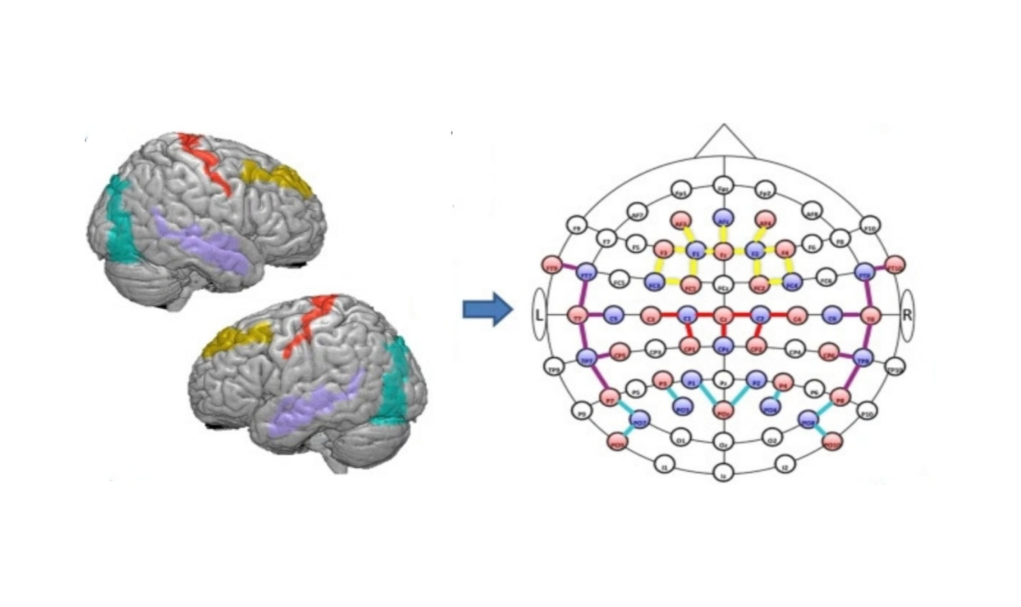

Fig.1.1 FNIRS Optodes’ Location Decider (FOLD):

2.2 Mechanism of Brain Reading Robots

The Brain reading actually involves measuring the volume and oxygen level of the blood around the subject's brain, using technology called functional near-infrared spectroscopy (FNIRS). The user wears a sort of futuristic headband that sends light in that spectrum into the tissues of the head where it is absorbed by active, blood-filled tissues. The headband then measures how much light was not absorbed, letting the computer gauge the metabolic demands that the brain is making. The results are often compared to an MRI, but can be gathered with lightweight, non-invasive equipment.

2.4 Applications of Brain Reading Robots

The Brain reading has its applications in many fields and some of its applications are as follows:

* By using the Brain -reading system the bankruptcy can be predicted.
* Brain reading has its application in facial recognition.
* Brain reading helps in converting the thoughts into speeches.
* It also helps the paralytic patients.

2.5 Major Factors leading Growth of Revenue in the Brain Reading Robots

Market:

* Growing acceptance of robotics and automation for carrying out routine, everyday task.
* A rising focus on minimizing human labor.
* Introducing robotics to the medical field.
* Patients with physical limitations can execute tasks with brain -reading robots.

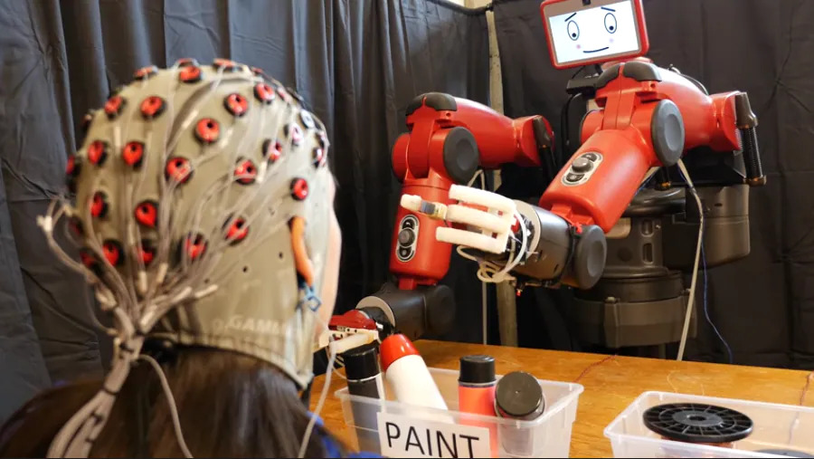

Fig 1.2 Robots That Is Controlled By Human Brain

3. ADVANCEMENTS IN BRAIN READING ROBOTS

* Robots have been a huge part of our lives for decades and they have been advancing at a rapid rate. Some robots have medical uses, such as in surgery or prosthetic limbs. And now, social robots are becoming a normal thing in the lives of people. They are being used as a tool for therapy in nursing homes and are even becoming a normal part of our children’s education. It’s expected that by 2050 there will be about 100 million robots in our midst!
* Fast-paced environments need robots that are intelligent enough to understand and respond in a way that shows an understanding of human intention. The electric activity in a human brain can be tracked and can help provide valuable information about what a person is thinking, which is why it’s an important technology to develop because it would not only help set up the proper expectations for consumers but would also help you design better marketing strategies.

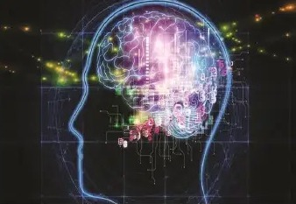

Fig 1.3Brain-computer interface (BCI)

4. CONCLUSION

Brain-computer interface (BCI) is a method of communication based on voluntary neural activity generated by the brain and independent of normal output pathways of perifera nerves and muscles. The neural activity used in BCI can be recorded us in invasive or non- invasive techniques .We can say as detection techniques and experimented designs improve, the BCI will improve as well and would provide wealth alternatives for individuals to interact with their environment. Electro encephalography is the process of recording the electrical activity in the brain.

**BIBILIOGRAPHY**

1. [**http://www.wikihow.com/Make-People-Think-You-Can-Read-Minds**](http://www.wikihow.com/Make-People-Think-You-Can-Read-Minds)
2. [**https://www.dictionary.com/browse/mind-reading**](https://www.dictionary.com/browse/mind-reading)
3. <https://www.bing.com>
4. [**https://www.wissenresearch.com/blogs/emerging-technology-in-mind-reading-robots/**](https://www.wissenresearch.com/blogs/emerging-technology-in-mind-reading-robots/)
5. [**https://www.reportsanddata.com/report-detail/brain-reading-robots-market**](https://www.reportsanddata.com/report-detail/brain-reading-robots-market)